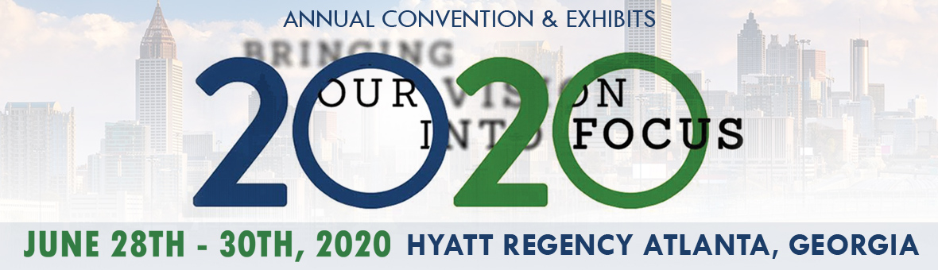
HOTEL INFORMATION

We have secured a group rate of $159.00 at the Hyatt Regency Atlanta (2 Queen beds or 1 King) We strongly recommend that you book your hotel needs early as it is expected that our room block will fill up fast and area hotels may be sold out due to the popular summer month and competing area events. The group rate includes a 30% discount on the hotels valet parking. Several self-parking lots are available in the adjacent blocks.

The Convention and Exhibits will be conveniently located in the host hotel.

Use the booking link on the website to assure to get the lowest price available and are protected within our group block.

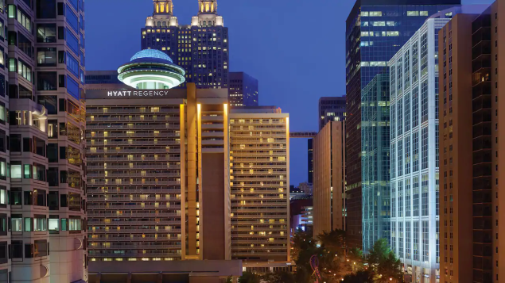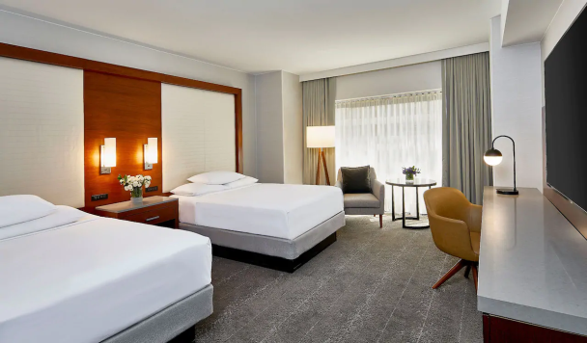

Stay in the Heart of Downtown Atlanta
Hyatt Regency Atlanta is a 30-minute train ride (MARTA) from the airport and a short walk to Atlanta’s stadium, convention center, and top attractions. The hotel is home to Georgia’s largest hotel ballroom and Polaris, Atlanta’s famous rotating lounge. The acclaimed chefs partner with 70 area farms to serve truly local dining experiences.
Area Attractions

The hotel offers easy access to Atlanta's most popular attractions. Take a stroll around downtown and check out the Georgia Aquarium, World of Coca-Cola, Center for Civil and Human Rights and the College Football Hall of Fame. Or hop on MARTA, directly linked to our hotel, and enjoy a day of fun in nearby neighborhoods, from Buckhead and Midtown to West Midtown or Inman Park.

